# HECAP Admin App Requirements for C24

# Introduction

# Use Cases

Epic 🡪 SQL database 🡪 HECAP app 🡨🡪refer to C24

## Use case 1: List patients from Epic

All the patient profile is stored in a SQL database table as below:

Server: hecapprodsql.database.windows.net

Database: hecapproddb

Table: he.PATIENT_C24

HECAP Admin App shall provide a web UI to list the key patient information. The list shall contain the following fields: First Name, Last Name, Phone, Email, MRN, FHIR ID, Status.

Use case 2: Query patients

The web UI shall provide a graphic query tool which can query the patient profile data by patient’s first name, last name, MRN or FHID ID

Use case 3: Display detailed patient profile data from C24 (In second release.)

In the patient list table, there are only several key profile data are listed. Web UI shall be able to display all the data in patient profile table. These detailed patient profile data can be displayed by clicking the patient row in the table.

Use case 4: Automatically send the patient profile data to C24 through API daily

HECAP Admin App shall send the patient profile data to C24 automatically daily. The data specification refers to C24 API guide.

# Workflow

Use case 1 to 3 are simple use case, the workflow is straightforward. So there is no need to document it.

Use case 4:

An automatic job shall be created in Web App.

* This job shall running at least once a day
* It shall select only the new user profiles which have not sent to C24 from table he.PATIENT_C24
* Convert the selected data into Json format based on C24 API specifications
* Send the data to C24 API server

# UI Prototype

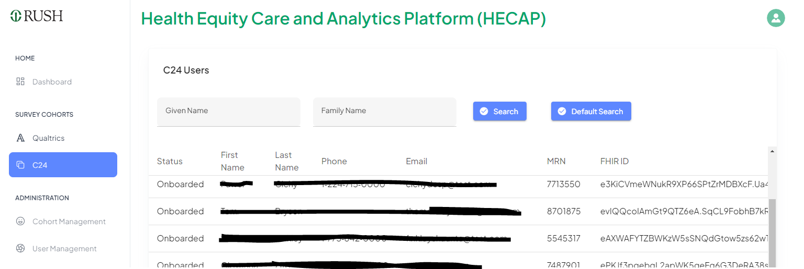

There is a separate API connection to send blood pressure data back from C24 to HECAP